1.1: ABOUT CLAMAVSCAN
- ClamAntivirus(ClamAv) is one of the most widely used open-source antivirus toolkits avaiable. It was initially developed for Unix systems but later a Windows version was produced. The toolkit consists of various command line programs such as virus signature generator as well as core scanner library.
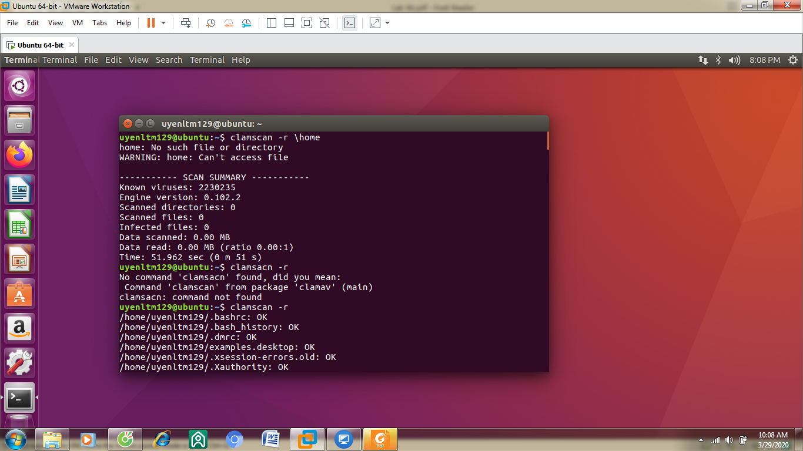

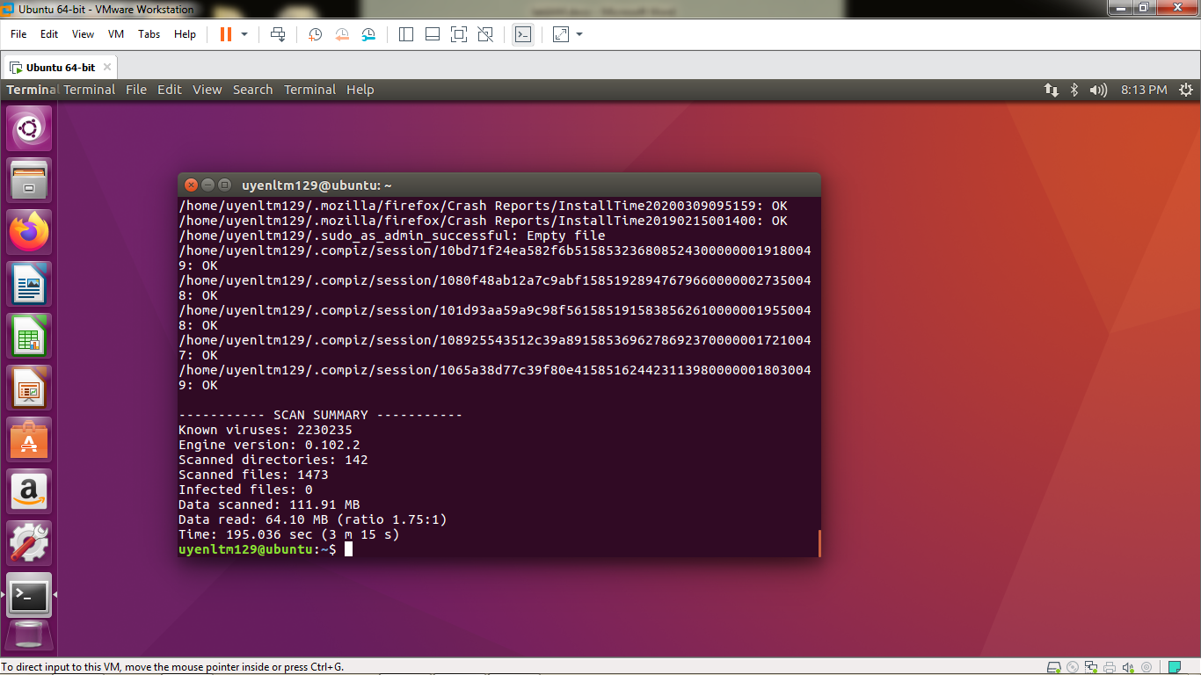

- Use link to download a example Sample Malware
- - This Sample Malware was created by Palo Alto Networks, leading network security company .
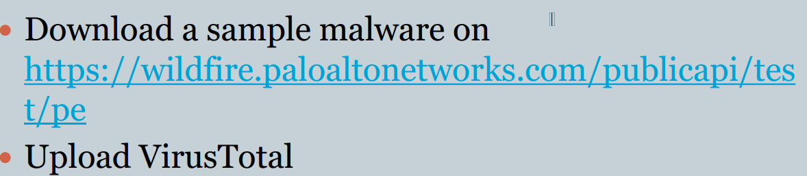
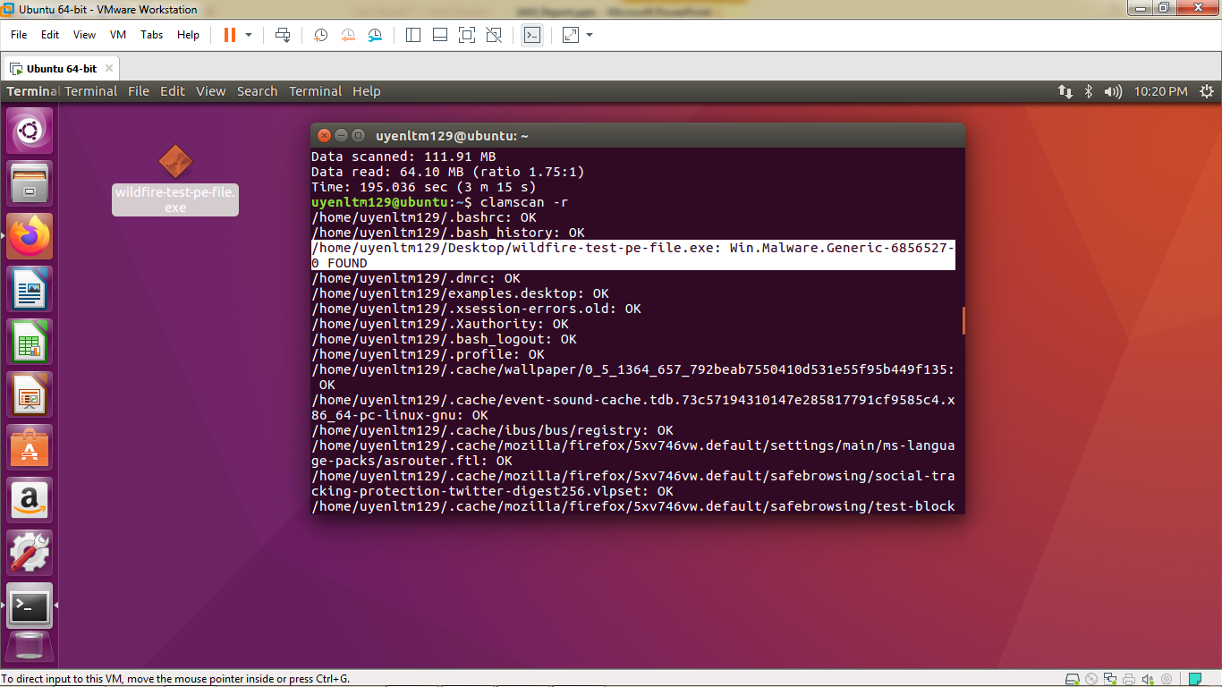
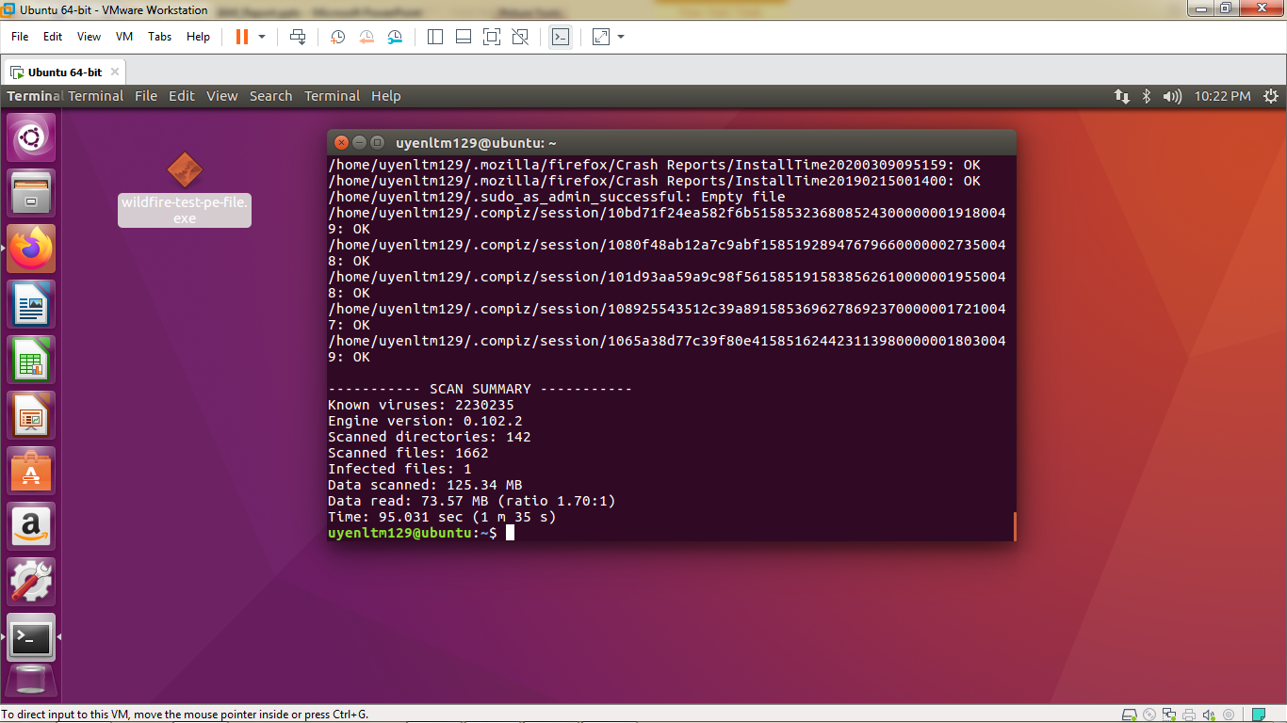
- If the rule is formatted correctly, clamscan will load the signature(s) in and scan any files specified via the command line invocation (or all files in the current directory if none are specified). A successful detection will look like the following:
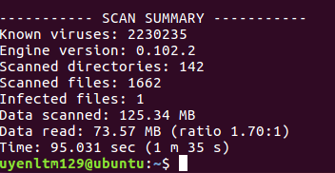

- After Scan all System, ClamAv will tell us about the Malware name and location of Malware found by marking FOUND, with file that doesn’t contain Malware will be notified as OK .
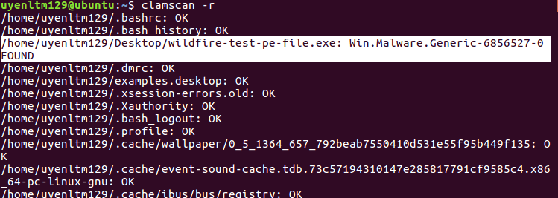
1.2 :ClamAV malware signatures
- ClamAV supports the two types of virus signatures – byte and hash signatures. Each of them has its advantages as well as disadvantages.

- For instance, hash signatures are useful if the malware you are trying to detect is old and non-changing. The problem with this kind of detection is that modern viruses are polymorphic which means they could change their structure. Modifying the infected file in any way makes the hash algorithm which generates the signature produce different result and leaves the malicious file undetected. On the other hand, the byte signature could not be bypassed that easily. This kind of signature relies on a string-matching algorithm to find the specific bytes in the file that make it malicious. ClamAV’s approach to byte signature detection is to use the Aho-Corasick pattern matching algorithm. The particular advantage of this algorithm is that it is multi-pattern exact matching and the running time is independent of the number of patterns.
- In comparison with algorithms like Bayer-Moore string search algorithm which uses pre- processing to skip sections of the text, Aho-Corasick constructs finite automaton from the patterns searched for and then it uses it when the actual string matching begins. The algorithm’s usefulness in anti-virus programs comes from the possibility to have the automaton constructed from the large number of signatures beforehand.
1.2.1: Hash signature format
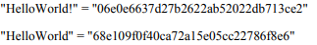
- ClamAV uses a MD5 hashing function to create its signatures. It requires three attributes to be present before it could create the signature format. The first one is the file size in bytes, the second one is the MD5 hash of the file and the third one is the file location. These attributes are separated by a colon and saved in a file with an extension “.hdb”
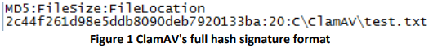
- As mentioned earlier using full hash signatures could be a liability that anti-virus software could not afford. That’s why ClamAV supports partial hash signatures in addition.

- These signatures are useful when the code of the executable does not change but the data it uses does. In this situation the partial hash signature is a good option to hash only the code section of the executable. ClamAV’s partial hash signature format is as follows: first the section name (“.code”), the section hash and then the malware name.

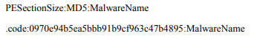
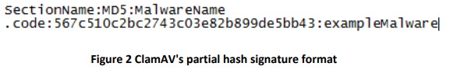
- Once the signature is created it could be saved into a file with extension “.mdb”

1.2.2: Byte signature format
- Byte signatures could represent any type of data such as code or data inside a data stream of an executable. The criterion for a good byte signature is that it should exist in multiple variants of malware from the same family. Hence it should minimize the virus free files that it detects as infected (false positives) and the infected files that it does not flag as malware (false negatives).
- Similarly to the hash signature, the byte signature format of ClamAV consists of three attributes separated by a colon:
+ The first one is usually the malware family.
+The second one is a value for what types of files the engine to scan for. The value “0” means any file, meanwhile “1” is only for Portable Executable files (.exe, .dll, .acm etc.).
+The third attribute is a sequence of bytes the engine is going to look for in the file (the byte signature).
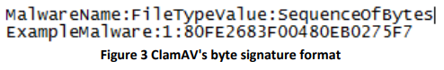

1.3: ClamAV heuristic
- Heuristic-based detection comes when the signature-based detection fails.
- The heuristic engine scans for certain instructions or commands within executable that are not found in typical software applications. As a result anti-virus software vendors are able to detect potentially malicious functionality in previously uninspected files.
- Generally there are two types of heuristic detection – a rule based and weight based system.
- The weight –based system is one of the first heuristic that appeared. This type of system works by analysing the each of the functionality of the file, giving it a weight and adding it to a value. At the end that value is compared against a threshold and if it is higher the file is a malware. The really big drawback of that technology is that it causes a lot of false positives. For instance, if non-infected file has a lot of copy operations it is very likely to be flagged as malware. For this project we focus on this kind of heuristic.
- The rule based system is the more modern of the two and nearly all anti-virus applications use it nowadays. This type of heuristic uses a component of its engine to extract rules from the potentially malicious file and compare them against pre-defined set of rules. If a match occurs, the file could be considered malware. It is very important in rulebased systems the rules to be exact so that it minimizes the false positives. ClamAV’s heuristic engine is based on a rule system

